Name: PRINCE OGWU

SQL Cohort2 Assignment2

Date: 22/11/2022

/\*Question 1

We need to send emails to our customers about a campaign. \*/

SELECT

   a.Title, a.FirstName, a.LastName,b.EmailAddress,  c.PhoneNumber

FROM

   [Person].[Person] a

INNER JOIN

    [Person].[EmailAddress] b

ON

a.BusinessEntityID = b.BusinessEntityID

INNER JOIN

    [Person].[PersonPhone] c

ON

    b.BusinessEntityID = c.BusinessEntityID;

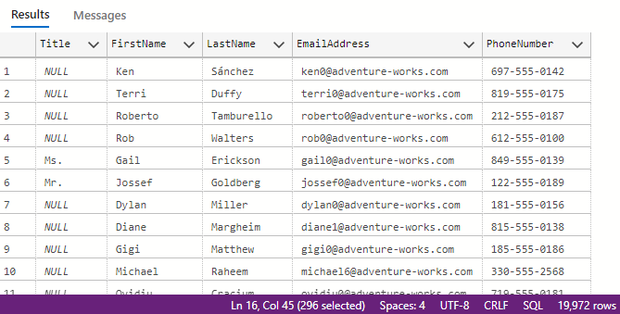

/\*Question 2

Using the [Person].[PersonPhone] table. Classify phoneNumbertypeid 1 as Cellphone

phoneNumbertypeid 2 as Landline, phoneNumbertypeid 3 as Fax mnumber \*/

/\*SELECT DISTINCT a.PhoneNumberTypeID

FROM Person.PersonPhone a;\*/

SELECT

    p.\*,

CASE

    WHEN phoneNumbertypeid = 1 THEN 'Cellphone'

    WHEN phoneNumbertypeid = 2 THEN 'Landline'

    ELSE 'Fax number'

END AS PhoneType

FROM

    person.PersonPhone p;

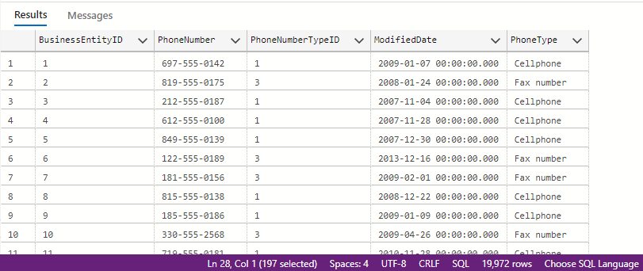

3a. INNER JOIN:

-This return only the matching rows from both tables and evryother thing will be discarded.

SELECT

    a.FirstName,a.LastName,a.PersonType,b.NationalIDNumber,b.JobTitle,b.BusinessEntityID,b.MaritalStatus,b.HireDate

FROM

[Person].[Person] a

INNER JOIN [HumanResources].[Employee] b

ON a.BusinessEntityID = b.BusinessEntityID;

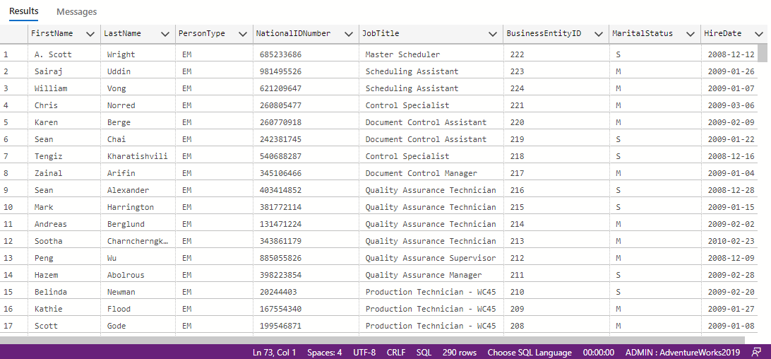

3b. LEFT JOIN:

LEFT JOIN: This returns all rows from the first Table(left table) and pairs with matching columnson the second table(right table).

SELECT

    a.FirstName,a.LastName,a.PersonType,b.NationalIDNumber,b.JobTitle,b.BusinessEntityID,b.MaritalStatus,b.HireDate

FROM

[Person].[Person] a

LEFT JOIN [HumanResources].[Employee] b

ON a.BusinessEntityID = b.BusinessEntityID;

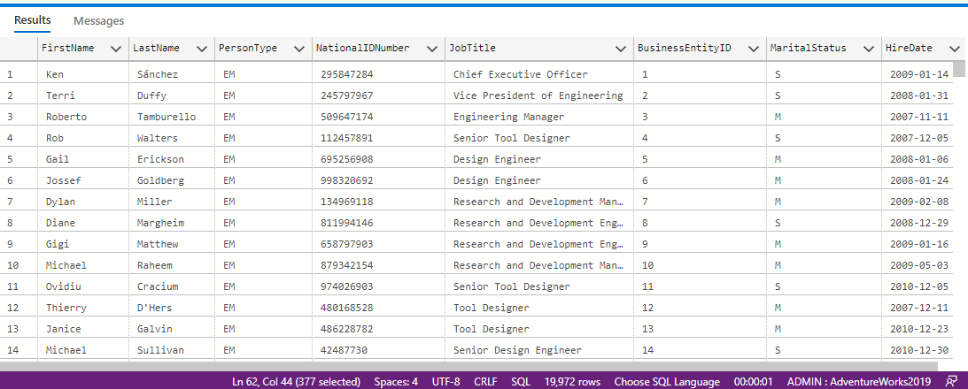

3c. RIGHT JOIN

RIGHT JOIN: This is the opposite of LEFT Join, It returns all tables from the right(Table2) and pairs with matching rows on the left(Table1).

SELECT

    a.FirstName,a.LastName,a.PersonType,b.NationalIDNumber,b.JobTitle,b.BusinessEntityID,

b.MaritalStatus,b.HireDate

FROM

[Person].[Person] a

RIGHT JOIN [HumanResources].[Employee] b

ON a.BusinessEntityID = b.BusinessEntityID;

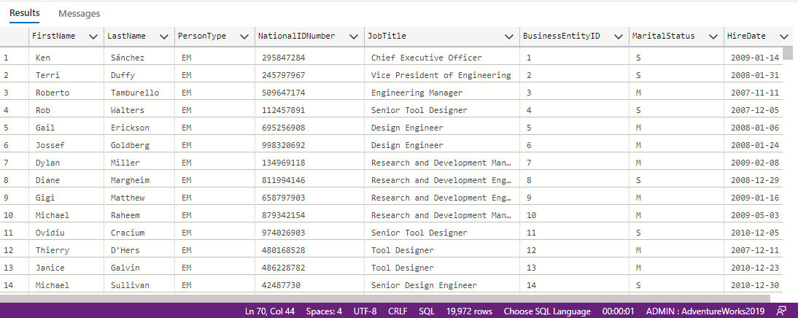

3d. OUTER JOIN

This returns both matched and unmatched records from both tables

SELECT

    a.FirstName,a.LastName,a.PersonType,b.NationalIDNumber,b.JobTitle,b.BusinessEntityID,b.MaritalStatus,b.HireDate

FROM

    [Person].[Person] a

FULL OUTER JOIN [HumanResources].[Employee] b

ON a.BusinessEntityID = b.BusinessEntityID;

